**1. Set up an Account as an Author**

First, you will need to set up an account (username and password) as an author. Go to  [https://www.easychair.org/conferences/?conf=acssi201](https://www.easychair.org/conferences/?conf=acssi2014)4. This link will bring up a login page for ACSSI 2014 (Figure 1). Select “sign up for an account” to register an account.

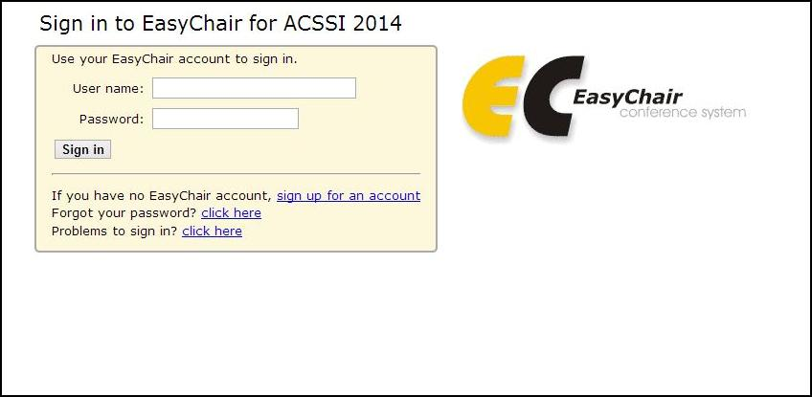

Figure 1. The login page of „EasyChair‟ for ACSSI 2014

You will then be automatically directed to a new page (as shown in Figure 2). Fill in the textbox with the distorted words that appear directly above it, and click on “Continue.”

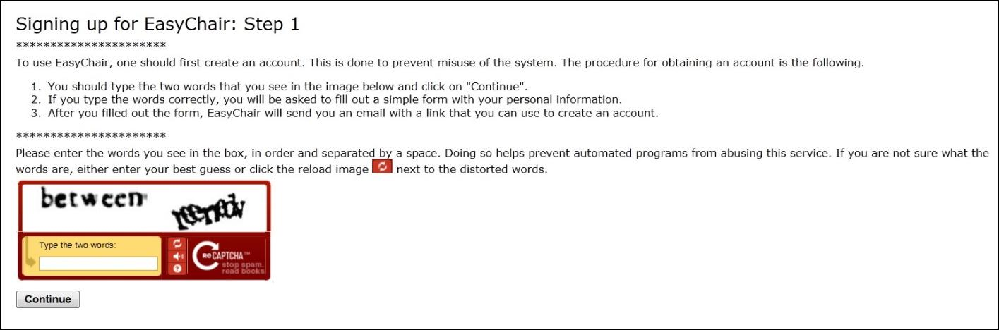

Figure 2. Enter information to sign up

Then, follow the on-screen instructions and complete the form (as shown in Figure 3), and click on “Continue.”

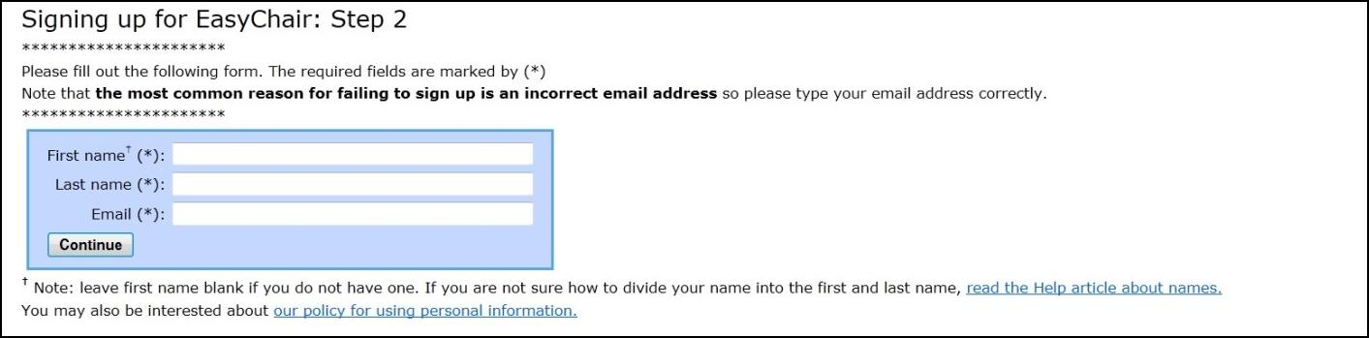

Figure 3. Fill out the form

After registering, you will receive an email similar to the one in Figure 4. Use the link provided in the email to continue the account registration process.

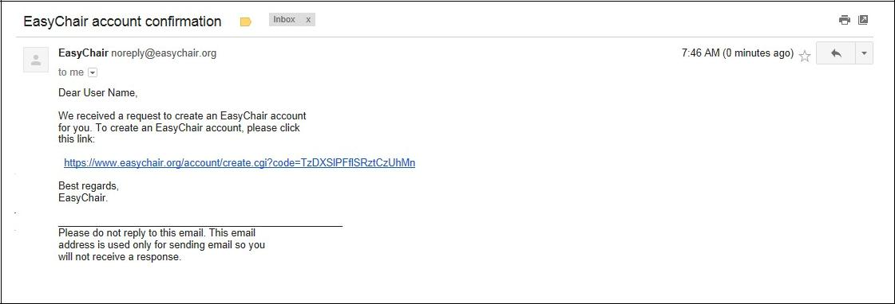

Figure 4. Login email

Fill out all of the required information (as shown in Figure 5), and click the “Create my account” button to finalize the account registration process.

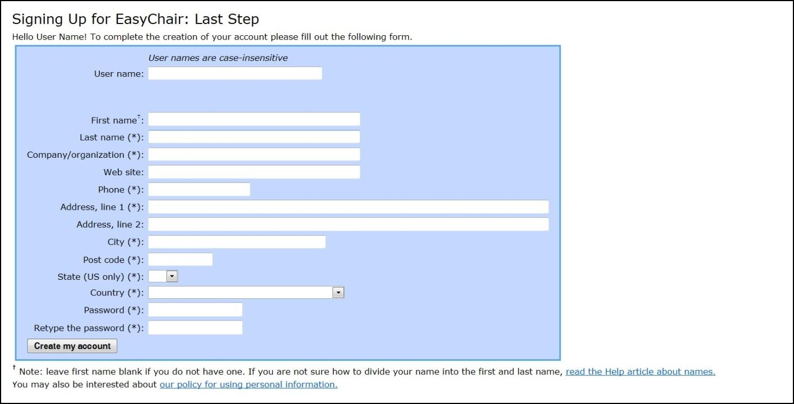

Figure 5. Create an account

After the account is registered, you may log in to the ACSSI 2014 simply by clicking on the “click this link” link (as shown in Figure 6).



Figure 6. Link to the login page

**Note:** If your username appears taken, it is possible that you have signed up for EasyChair inthe past for another conference. In this case, you simply need to ask the system to remind you of your password based on your username.

**2. Submit Your Abstract(s) by 15 February, 2014**

After logging in to the “EasyChair‟ website for the ACSSI 2014, you may click on the “New Submission” link located in the top-left corner of the menu bar to submit a new abstract (as shown in Figure 7).

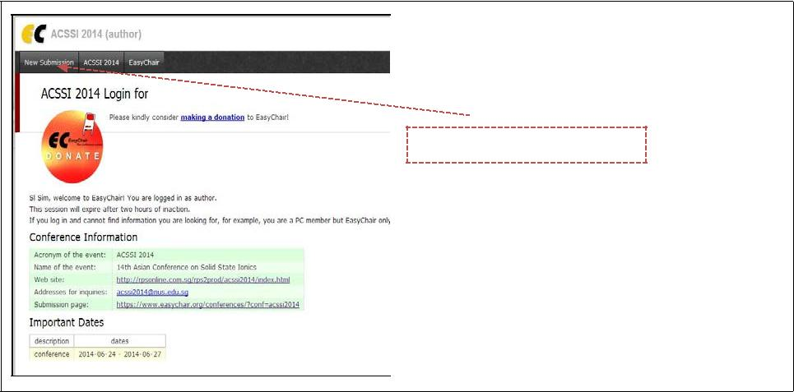

New Submission Click Here.

Figure 7. The main page for authors

Before submitting your abstract, you should select the track relevant to your submission (as shown in Figure 8). Please be careful with this step; once you select the track and click “Continue”, you cannot change the track on your own (you’ll have to request that the Chair change it).

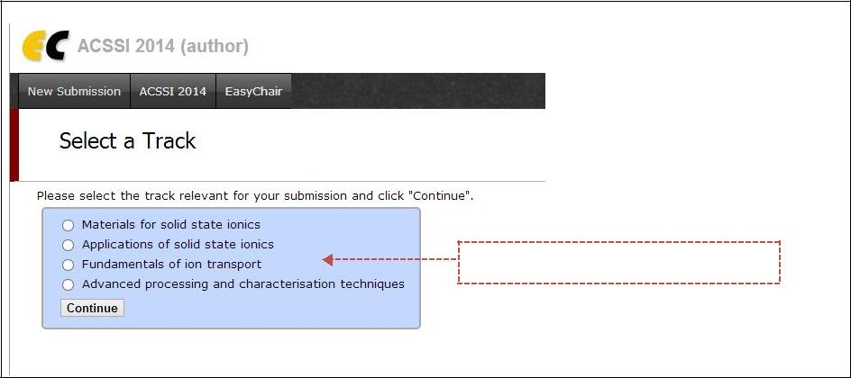

Select a track and click “Continue”

Figure 8. Track selection

Follow the on-screen instructions and fill out all of required information (as shown in Figure 9). Once you have filled out everything (including ‘ Abstract’, **click on the box that says** **“Abstract only.” C**lick the “Submit” button to finish your abstract submission. **Abstract submission should not exceed 300 words.**

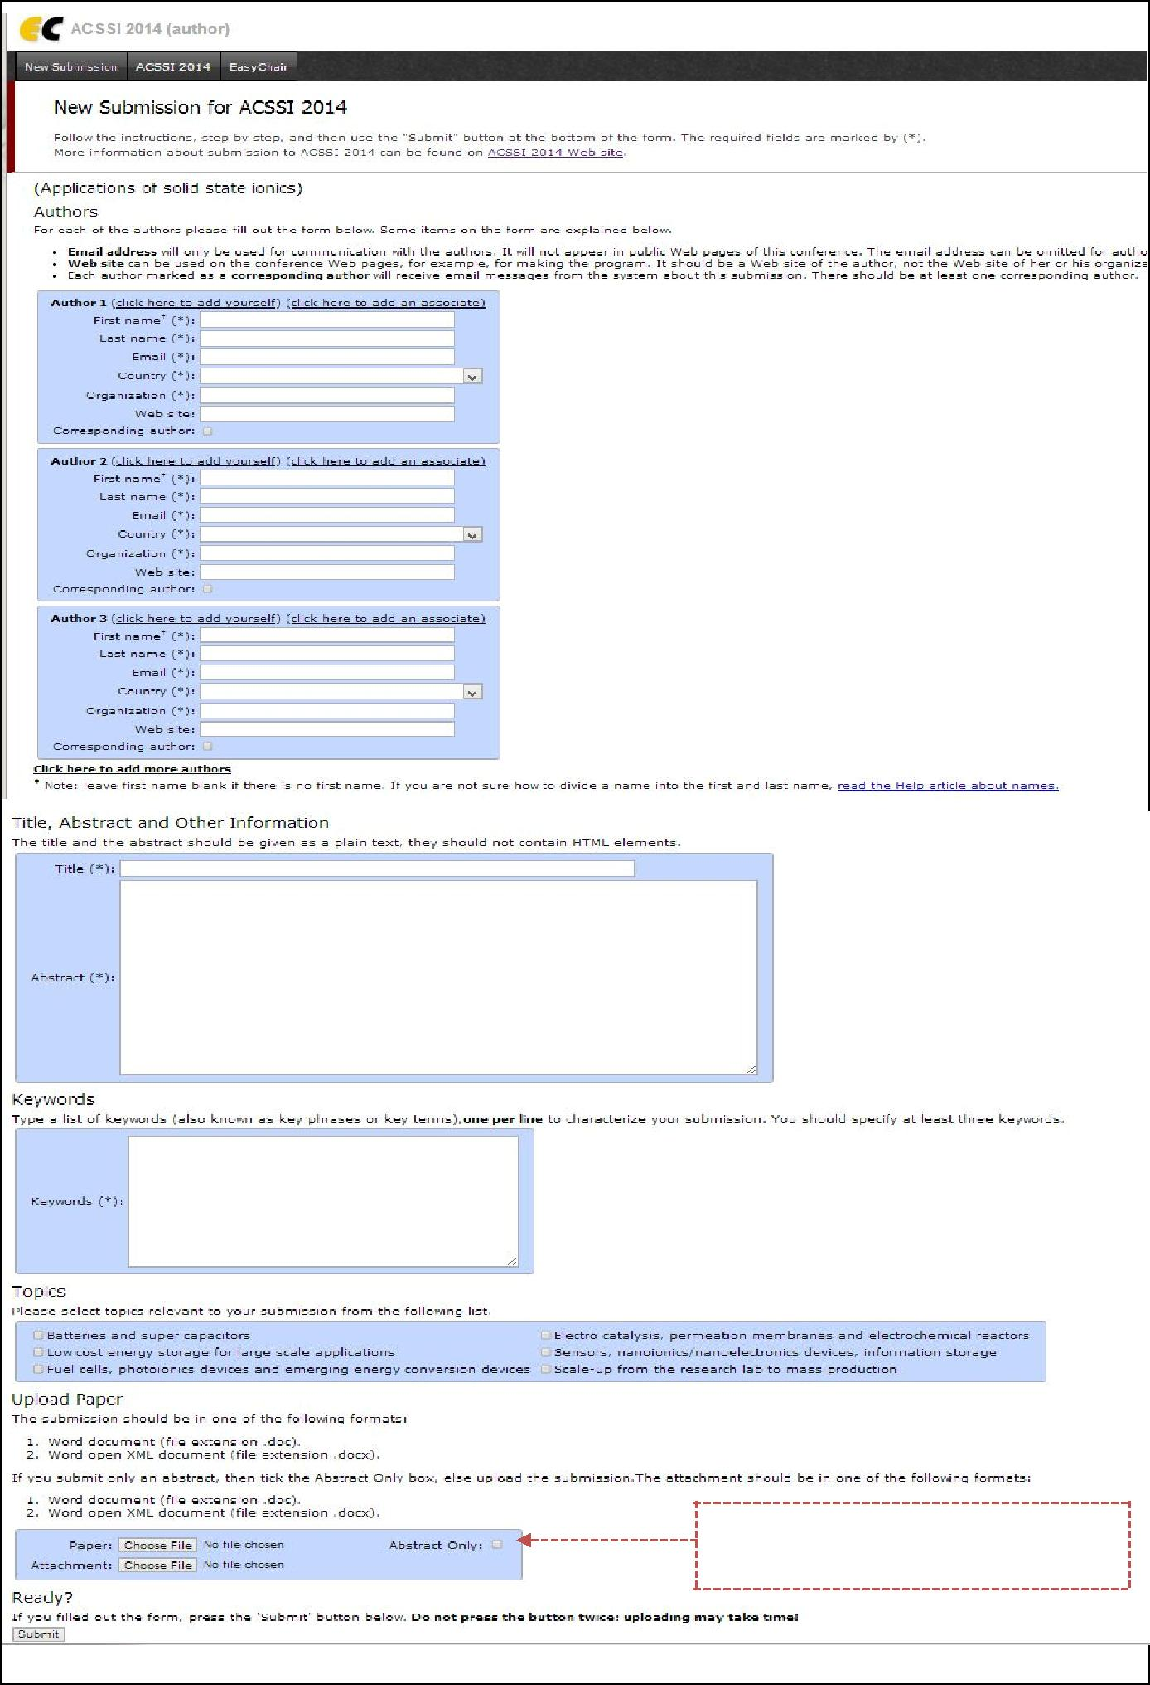

Upload your abstract – ensure “Abstract Only” is selected

Figure 9. Abstract submission

When the abstract submission is completed, you can check the submitted information and make changes (as shown in Figure 10).

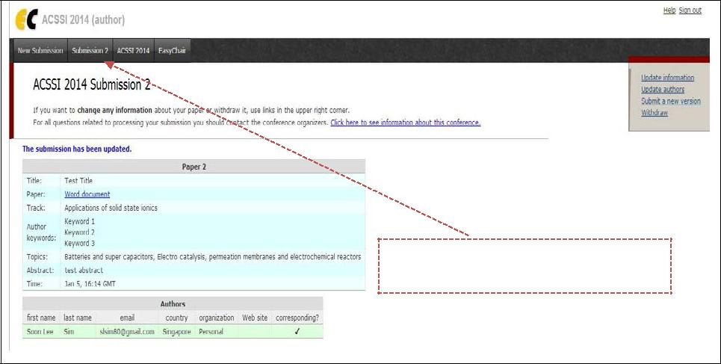

After submission, a new menu bar is created. Click to change submission

Figure 10. Changing your submission(s)

* **Updating information about your submission:** Select “Update information” fromthe right-hand menu of the Submission screen; correct information as desired then press the “Change Information” button to save alterations.
* **Updating author information for your submission:** Select “Update authors” fromthe right-hand menu of the Submission screen; correct any information about the author(s) and click “save.” In the case of multiple authors, you can add (“Add new author”) or remove authors (Click on “X”); then update the order of the authors by selecting the “Reorder authors” button.
* **Submitting another version of your abstract**: If you want to change the uploadedabstract, select “Submit a new version” from the right-hand menu of the Submission screen. Next, select the file from your computer that you wish to upload. Then submit your new abstract by selecting the “Submit a New Version” button.

At the end of the submission procedure (a new submission or an update of an old one), you will receive a confirmation e-mail from  acssi2014@easychair.org.

Once the review process is completed, you will receive acceptance/rejection notification with reviews by email (abstract decisions will be provided by 28 February, 2014). In addition, you may check the reviews by clicking on “Submission #,” located in the top-left corner of the menu bar (as shown in Figure 11).

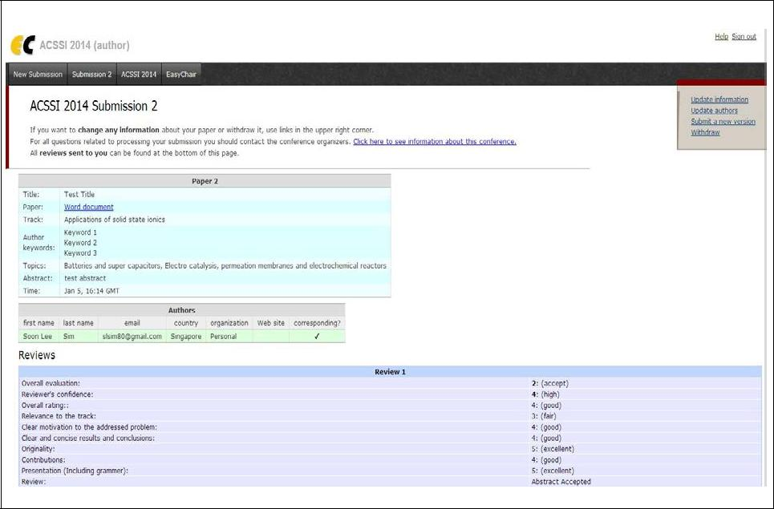

Figure 11. View reviews of the abstract

1. **Manuscript Submission by 26 April, 2014** 
   * An author whose abstract was accepted can submit a manuscript.

You can submit a full manuscript **only by updating the submission you submitted as an** **abstract** (as shown in Figure 12). You may change the title, abstract, and keywords byselecting “Update information.” You may also update authors using the “Update authors” page. Most importantly, you have to submit a manuscript by selecting “Submit a new version” from the right-hand menu of this screen.

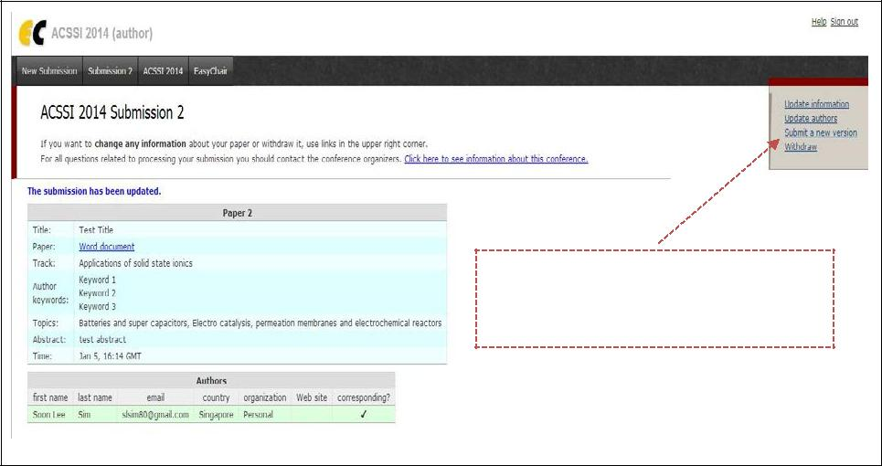

Submit the manuscript by selecting “Submit a new version” from the right-hand menu.

Figure 12. Full paper submission

* **Updating information about your submission:** Select “Update information” fromthe right-hand menu of the Submission screen; correct and fill out the form, and press the “Change Information” button.
* **Updating author information for your submission:** Select “Update authors” fromthe right-hand menu of the Submission screen; correct any information regarding the author(s) and click “save.” In the case of multiple authors, you can add (“Add new author”) or remove authors (Click on “X”); then update the order of the authors by selecting the “Reorder authors” button.
* **Uploading the manuscript**: Select “Submit a new version” from the right-handmenu of the Submission screen. Select the file from your computer that you wish to upload. Submit your manuscript by selecting the “Submit a New Version” button.